**7. Program to calculate students Grades using Dictionary**

**7.1 Aim**

Creating a module in Python read data of the students into a dictionary and find the average grades.

**7.2 Software Used**

1. Anaconda Navigator
2. Jupyter Notebook

**7.3 Pre Lab Questions**

1. Create a dictionary for five states and capital. Print the same.

2. Modify the value/Key value in the dictionary by adding two more states

and capitals.

3. How to delete a specific value in a dictionary?

4. Is a python dictionary modifiable? Write one example

**7.4 (a) Algorithm**

1. Create a dictionary with the key of Student name, assignments, test and lab mark.

2. Create database for five students using step1.

3. Create a function “get_average” to find avg. marks of assignment, test and lab

Marks

4. Create a function “calculate_total_mark” to find total marks based on weightage

of assignment, test and lab marks

5. Create a function assign_letter_grade to allocate grade based on the specification

6. Create a Function to calculate the total average marks of the whole class

7. Execute the program enter input and check the final result

**Formula 1: calculate Grade based on total mark**

score >= 90 : **"A"**

score >= 80 : **"B"**

score >= 70 : **"C"**

score >= 60 : **"D"**

for other : ”E”

**Formula 2: calculate total marks based on weightage of each component**

# Return the total marks based on weightage supplied

# 10 % from assignments

# 70 % from test

# 20 % from lab-works

# 1 & 2 .Creating a dictionary which consists of the student name, assignment, Lab, test marks

#s1 to s5 are dictionary of five students

# 3.Function to calculates average marks

# 4.Function to calculates total mark for each student based on weightage of assignment,test and lab mark

# Return the total marks based on weightage supplied

# 10 % from assignments

# 70 % from test

# 20 % from lab-works

# Grade will be calculated according to

# 1. score >= 90 : **"A"**

# 2. score >= 80 : **"B"**

# 3. score >= 70 : **"C"**

# 4. score >= 60 : **"D"**

# 5 Calculate letter grade of each student

# Function to calculate the total average marks of the whole class

# Student list consisting the

# dictionary of all students

# Iterate through the students list and calculate their respective total marks and letter grade

# 6.Calculate the average of whole class

**Program:**

student = {

'name': 'Kunal',

'assignments': 45,

'test': 50,

'lab mark': 89,

}

print(student)

students = [

{

'name': 'Kunal',

'assignments': 45,

'test': 50,

'lab mark': 89,

},

{

'name': 'Louhith',

'assignments': 100,

'test': 100,

'lab mark': 100,

},

{

'name': 'Sangam',

'assignments': 69,

'test': 69,

'lab mark': 69,

},

{

'name': 'Sandeepan',

'assignments': 95,

'test': 100,

'lab mark': 99,

},

{

'name': 'Harish',

'assignments': 96,

'test': 100,

'lab mark': 80,

},

{

'name': 'Likhit',

'assignments': 80,

'test': 100,

'lab mark': 85,

}

]

print(students)

def calculate_total_marks(list):

for student in list:

total = student['lab mark'] + student['test'] + student['assignments']

student['total'] = total

return list;

print(calculate_total_marks(students))

def get_average(list):

for student in list:

student['average'] = (student['total']/300)*100

return list;

print(get_average(students))

def total_average_marks_of_class(list):

class_len =len(list)

class_average = []

for student in list:

class_average.append(student['average'])

return (sum(class_average)/class_len)

print(total_average_marks_of_class(students))

def grade_based_on_mark(list):

for student in list:

if(student['average'] >= 90):

student['grade'] = 'A'

elif(student['average'] >= 80):

student['grade'] = 'B'

elif(student['average'] >= 70):

student['grade'] = 'C'

elif(student['average'] >= 60):

student['grade'] = 'D'

else:

student['grade'] = 'E'

return list;

grade_based_on_mark(students)

for student in students:

print(student['name'], 'scored', student['grade'], 'grade')

**Output response:**

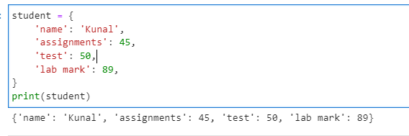

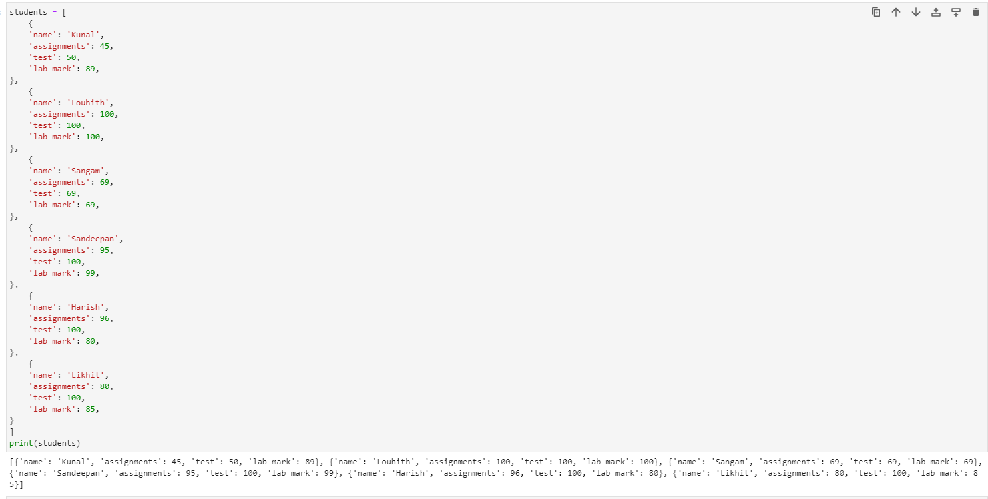

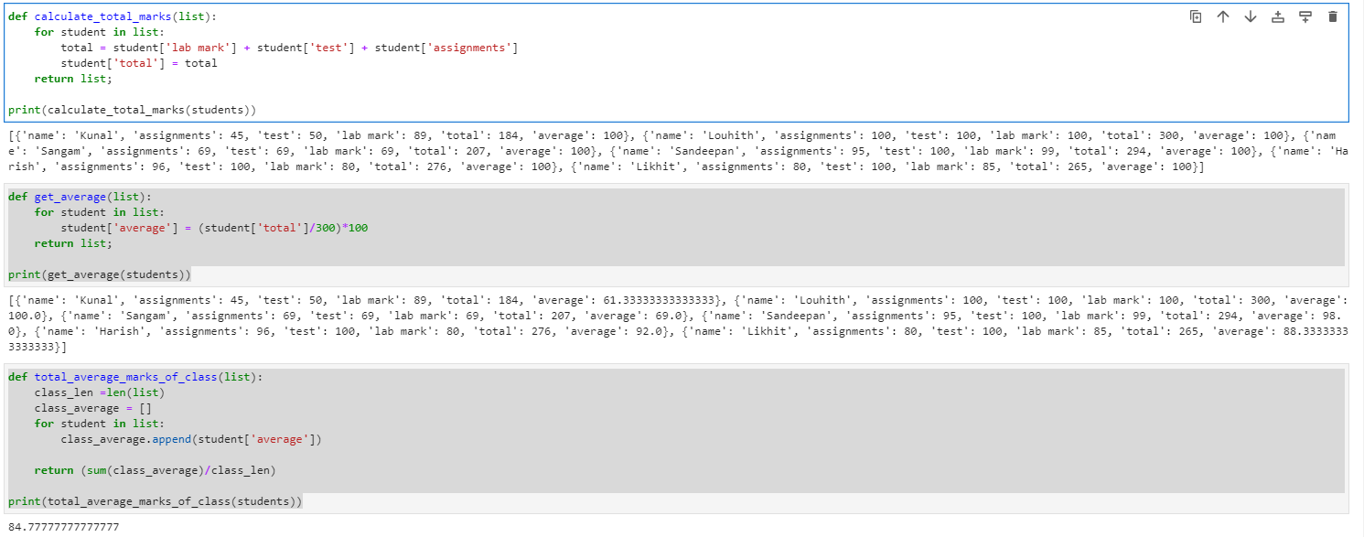

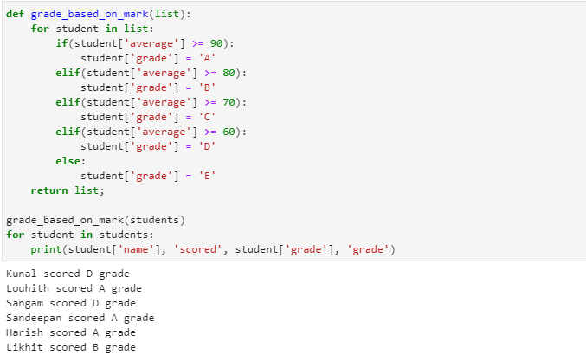

**7.4 (b) Follow the steps bellow: -Create a new dictionary called prices using {} .**

Put these values in your prices dictionary:

"banana": 4,

"apple": 2,

"orange": 1.5,

"pear": 3

Loop through each key in prices. For each key, print out the key along with its price and stock information. Print the answer in the following format:

apple

price: 2

stock: 0

* Let's determine how much money you would make if you sold all of your

food.

* Create a variable called total and set it to zero.
* Loop through the prices dictionaries. For each key in prices, multiply the

number in prices by the number in stock. Print that value into the console

and then add it to total.

* Finally, outside your loop, print total.

**Program:**

#Create the prices dictionary:

#Add values

#Create the stock dictionary

#Add values

#Show all prices and stock

for food in prices:

prices = {

'banana': 4,

'apple': 2,

'orange': 1.5,

'pear': 3

}

stock = {

'banana': 8,

'apple': 0,

'orange': 2,

'pear': 6

}

for item in prices:

print(item)

print('price:', prices[item])

print('stock:', stock[item], '\n')

total = 0

for item in prices:

total = total + (prices[item]*stock[item])

print(total)

**Output response:**

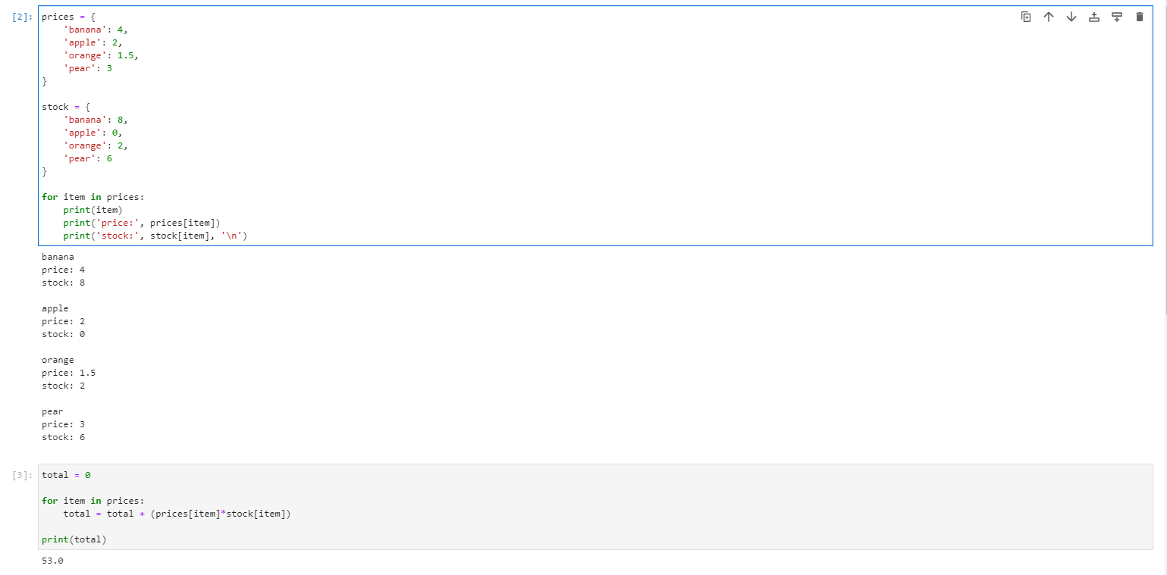

**7.5 Post Lab Question**

1. Write a program that accepts a sentence and calculate the number of letters and

digits in the given sentence

|  |
| --- |
| Suppose the following input is supplied to the program: |
| Scientific python! 2022 |
| Then, the output should be: |
| LETTERS 16 |
| DIGITS 4  **Hint :** use isdigit(), isalpha() function  2. Write a python program using dictionary to create a small dictionary (min of five words) of synonyms. the program should accept a word and generate synonyms for the same  **Hint:** same key with different value |

**7.6 Result**

Creating a module in Python read data of the students into dictionary, find the average grades and price verified the result.